DEVELOPMENT OF AN AI ASSISTED SMART FITNESS COACHING USING MEDIA PIPE

by

MORUF SHERIFFDEEN OLAREWAJU
AI/HND/F23/0028

A PROJECT SUBMITTED TO THE DEPARMENT OF ARTIFICIAL INTELLIGENCE, SCHOOL OF COMPUTING, FEDERAL POLYTECHNIC OFFA, KWARA STATE

IN PARTIAL FULFILLMENT OF THE REQUIREMENT FOR THE AWARD OF HIGHER NATIONAL DIPLOMA (HND) IN ARTIFICIAL INTELLIGENCE

June, 2025

CHAPTER ONE

Introduction

1.1 Background of the Study
The way people approach physical training and wellness has changed dramatically in recent years due to the introduction of artificial intelligence (AI) into the fitness and health sector. The demand for intelligent, easily accessible, and customized fitness solutions has increased due to the rising prevalence of sedentary lifestyles and the global emphasis on health awareness. Computer vision and machine learning are used by AI-based fitness coaching systems to provide real-time feedback, track user progress, and adjust postures without the need for human assistance (Wang et al., 2022). One of the most well-known technologies in this field is MediaPipe, a cross-platform real-time framework created by Google that has become well-known for its high-performance gesture recognition and human pose estimation (Lugaresi et al., 2019).
The increasing adoption of fitness applications and wearable technology has made physical health more accessible. However, many fitness apps lack real-time posture evaluation and personalized coaching, often leading to improper exercise forms that may cause injury or reduce effectiveness. With the advancements in computer vision and artificial intelligence, especially through tools like MediaPipe by Google, it is now possible to create AI-based systems that analyze human movement accurately and provide instant feedback.
The project suggests a reliable pipeline that uses the MediaPipe BlazePose model to detect human skeletal joints by processing video input in real-time. The quality of exercises like lunges, push-ups, and squats is evaluated by calculating joint angles and movement patterns using the landmarks that have been detected. The system then provides real-time corrections, either visually or audibly, by comparing user movements to preset thresholds or ideal patterns (Mishra et al., 2025).
Data collection, preprocessing, pose detection, performance assessment, and user feedback are some of the stages of development that are included in the methodology. The main programming language is Python, which integrates MediaPipe for skeletal tracking and OpenCV for video capture and frame analysis. Various user profiles and exercise types are used to test the system's accuracy, latency, and usability.

1.2. Problem Statement
Even though the value of physical fitness is becoming more widely recognized, many people find it difficult to get professional advice because of things like cost, time, or location restrictions. Because of this, people frequently work out without the right supervision, which can result in bad posture, ineffective workouts, or even severe injuries. Conventional fitness apps offer written manuals or instructional videos, but they are unable to provide real-time, customized feedback based on the user's actual movements. This leaves a hole in the provision of safe, efficient, and flexible fitness experiences. An intelligent system that can assess posture, analyze human body movements in real time, and give users constructive criticism is desperately needed. By creating an AI-assisted smart fitness coaching system that uses real-time pose estimation to guarantee users complete exercises safely and correctly even in the absence of a human trainer, this study aims to solve this issue.

1.3. Aims and Objectives of the study
To develop an AI-assisted smart fitness coaching system using MediaPipe for real-time posture detection and feedback.
Objectives:
- To collect and preprocess video datasets of standard workout exercises.
- To implement a pose detection model using MediaPipe’s pose estimation.
- To classify the correctness of each exercise posture using a Convolutional Neural Network (CNN).
- To provide real-time visual/audio feedback to users based on posture assessment.
- To evaluate the system's performance using accuracy, precision, recall, and F1-score.

1.4 Significance of the Study

In order to meet the increasing demand for easily accessible, intelligent, and real-time fitness coaching solutions, this study is extremely valuable. The creation of an AI-assisted smart fitness coaching system offers a more affordable option to traditional personal training, enabling anyone, regardless of location or financial means, to receive high-quality exercise advice. Fitness enthusiasts, novices, remote workers, and people recuperating from injuries who need safe, supervised exercise regimens without close supervision will especially benefit from it. The methods and insights used in this study may also be useful to researchers and educational institutions working in the domains of computer science, artificial intelligence, and health informatics. All things considered, the project advances the more general objective of encouraging physical well-being via innovation driven by technology.

1.5. Scope of the Study

The scope of this study is limited to the development of an AI-assisted fitness coaching system that focuses on basic bodyweight exercises such as squats, push-ups, and lunges. It utilizes a webcam or smartphone camera to capture real-time video input, which is then processed using MediaPipe for pose estimation. The extracted pose data will be analyzed using a Convolutional Neural Network (CNN) to determine the correctness of the user’s posture.

1.6 Limitations of the Study

There were some restrictions on the study while it was being developed. Limited camera quality, background interference, and bad lighting all had an impact on pose detection accuracy. Additionally, because the system relied on general-purpose pose estimation, it struggled to handle complex or unusual movements. Furthermore, the scope was constrained by the absence of access to a sizable and varied dataset, which could have an impact on how well the system performs in various user and environmental contexts. The incorporation of sophisticated features like voice feedback and support for a greater variety of exercises was further restricted by time constraints and resource availability.

1.7 Definitions of Terms
Artificial Intelligence (AI): A branch of computer science that enables machines to simulate human intelligence, such as learning, decision-making, and problem-solving.
Smart Fitness Coaching: The use of intelligent systems and technologies to provide real-time guidance, monitoring, and feedback during physical exercises without human intervention.
MediaPipe: An open-source framework developed by Google that provides real-time perception solutions, including pose estimation for tracking human body movements.
Pose Estimation: A computer vision technique used to determine the position and orientation of a human body in an image or video by identifying key joints or landmarks.
OpenCV: A popular open-source computer vision library used for image and video processing in real-time applications.
Real-time Feedback: Immediate responses or guidance given by the system based on the user’s performance during exercises.
Computer Vision: A field of AI that enables computers to interpret and understand visual information from the world, such as images and videos.

CHAPTER TWO

LITERATURE REVIEW
2.1 Theoretical Concept

2.1.1 Machine Learning in Fitness Coaching
2.1.1 Machine Learning in Fitness Coaching
Machine learning has emerged as a transformative tool in fitness coaching, enabling personalized, data-driven training programs that adapt to individual needs. By analyzing large datasets from wearable devices, motion sensors, and camera-based systems, machine learning algorithms can assess performance, detect improper form, and provide real-time feedback to users (Wang et al., 2023). This approach reduces the reliance on constant human supervision while maintaining high accuracy in exercise evaluation.
Modern fitness coaching platforms integrate pose estimation algorithms—such as OpenPose, MediaPipe, and HRNet—with machine learning models to track joint movements and detect deviations from optimal exercise form. These systems can also predict the risk of injury, monitor progress over time, and recommend exercise modifications tailored to the user’s goals and physical capabilities (Kang & Lee, 2024).
The integration of deep learning models with cloud-based processing allows coaches and users to access fitness data and feedback remotely, enabling continuous monitoring regardless of location. Such innovations have been instrumental in the growth of virtual personal training, particularly during and after the COVID-19 pandemic, when remote fitness solutions became essential (Li et al., 2022).

2.1.2 Pose Estimation
Pose estimation is central to intelligent fitness coaching systems, as it enables the detection and real-time tracking of human body movements using computer vision. The process involves identifying anatomical landmarks such as shoulders, elbows, knees, and hips from RGB video frames, which are then used to infer posture, joint angles, and movement trajectories. Recent advances have enabled highly accurate markerless 3D pose estimation using only a single camera. For instance, a study in Heliyon (2024) demonstrated that using a single RGB camera and deep learning–based pose models, joint angle errors were kept within 10° RMSE when compared to a VICON motion-capture system, enabling reliable exercise evaluation for movements like squats, deadlifts, and jumps (Clara, et al.,2022). Such precision allows users to receive detailed feedback on body alignment and biomechanical correctness using only a smartphone or webcam.
Similarly, transfer learning techniques and pose landmark frameworks have been applied in remote exercise systems. A 2023 conference paper described a system based on the MoveNet model, capable of evaluating movements such as jumping jacks, squats, push-ups, and curls, enabling collaborative and competitive remote fitness experiences (Sho, et al, 2023).

2.1.2.1 Categories of Pose Estimation
Historically, pose estimation methods have been categorized into 2D and 3D approaches, each offering different insights and applications. 2D Pose Estimation focuses on identifying the coordinates of body joints in the two-dimensional image plane assigning X and Y coordinates per keypoint. This method is more computationally efficient and simpler to implement, but it lacks depth information, which limits its ability to fully understand spatial relationships or complex movement postures (Li et al., 2022).
In contrast, 3D Pose Estimation seeks to reconstruct the spatial coordinates of joints in three dimensions, including depth (X, Y, Z). This richer representation enables detailed analysis of anatomical movement, limb orientations, and real-world biomechanics, but it also introduces greater complexity and requires more sophisticated computational techniques (Chen et al., 2023).
Recent studies have shown that 3D estimation from monocular images often employs either one-stage or two-stage pipelines. One-stage approaches directly regress 3D joint positions from image features, while two-stage methods first predict 2D joint locations and then lift them into 3D space using learned models or parametric frameworks (Wang et al., 2024). The lifting-based methodology is particularly advantageous because 2D pose detectors are typically lightweight and widely available, making them a practical foundation for scalable 3D pose systems (Zhang et al., 2024).
Moreover, literature reviews emphasize that 3D pose estimation provides crucial depth data, which helps resolve ambiguities inherent in 2D projections especially in single-camera setups where similar 2D poses can correspond to different 3D configurations (Liu et al., 2023). This makes 3D pose estimation particularly relevant for applications requiring precise movement analysis, such as in biomechanics, fitness coaching, and rehabilitation (Huang et al., 2023).

2.1.2.2 Traditional Approaches to Pose Estimation
Before the introduction of modern machine learning and computer vision methods, pose estimation was primarily conducted using marker-based motion capture systems. These systems required placing reflective markers at specific anatomical landmarks on the subject’s body, which were then tracked by multiple high-speed infrared cameras to triangulate and compute joint positions (Ahmad et al., 2021).
Such systems were highly accurate and became the gold standard in biomechanics, sports science, and animation production. However, they had several limitations:
- High Cost: The hardware and software required were expensive, limiting accessibility for smaller research institutions and commercial projects.
- Controlled Environment Dependency: Data collection had to occur in specialized laboratories with carefully calibrated camera setups.
- Intrusiveness : Wearing reflective markers and tight-fitting suits often altered a subject’s natural movement, potentially introducing bias in motion analysis.
Despite these drawbacks, marker-based systems laid the foundation for understanding complex human motion and created benchmark datasets for validating emerging vision-based techniques. Many markerless pose estimation methods in use today aim to replicate or surpass the accuracy of these systems without their cost or setup constraints (Gonzalez et al., 2022).

2.1.6 Transition to Machine Learning-Based Pose Estimation
With the emergence of deep learning and convolutional neural networks (CNNs), pose estimation evolved from hardware-dependent systems to algorithms capable of learning complex spatial and temporal patterns directly from image and video data. Modern pose estimation frameworks now utilize large-scale annotated datasets and advanced neural architectures to achieve high accuracy without requiring specialized motion capture equipment, relying solely on standard cameras or recorded videos (Kang & Lee, 2024).
These advancements have significantly broadened the applicability of pose estimation, making it accessible to sports coaches, physiotherapists, healthcare practitioners, and fitness applications in everyday environments.
Machine learning driven systems such as OpenPose, MediaPipe, and HRNet—have outperformed traditional marker-based approaches in robustness, adaptability, and processing speed. They are capable of detecting multiple individuals in complex environments, handling partial occlusions, and performing real-time tracking using ordinary video streams. This democratization of pose analysis has shifted the technology from specialized labs into mainstream consumer and professional use (Zhang et al., 2025).

2.1.3 Computer Vision in Fitness Coaching
Computer vision plays a crucial role in AI-assisted fitness coaching, enabling the system to interpret visual data and translate it into actionable fitness guidance. At the heart of this process is pose estimation, where algorithms analyze live video feeds from a standard camera to locate and track key points on the human body. These key points are then used to compute joint angles, assess posture, count repetitions, and evaluate exercise form in real-time.
For example, a 2023 study described the design of a fitness movement detection and counting system that integrates MediaPipe with OpenCV. It emphasized the use of a lightweight model for fast and accurate skeletal keypoint detection, enabling efficient movement counting and form validation within a user-friendly interface (Soham, et al., 2025) and (Yinan Chen and Xia Liu, 2023). Similarly, an AI-powered body detection and teaching system implemented with MediaPipe and OpenCV demonstrated how the system could capture movements via camera, assess correctness, and deliver real-time auditory and visual feedback in a rehabilitation (Li, et al, 2022).

2.1.4 Exercise
Exercise refers to planned, structured, and repetitive physical activity that is purposefully designed to maintain or improve physical fitness and overall health. Unlike incidental physical activity, exercises are performed with specific goals such as enhancing strength, flexibility, endurance, or rehabilitation.
Research consistently shows that regular exercise triggers beneficial metabolic and cardiometabolic adaptations, including improved insulin sensitivity and blood glucose regulation, reduced systemic inflammation, and enhanced metabolic function in tissues like the liver, skeletal muscle, and adipose tissue (PubMed, 2023). Additionally, exercise induces the release of bioactive molecules called exerkines, which play critical roles in mediating systemic health effects such as weight management, metabolic homeostasis, and resistance to chronic diseases like type 2 diabetes and obesity (PubMed, 2022). Exercise also functions as an effective tool in the prevention and mitigation of metabolic diseases, promoting improved metabolic and cardiovascular profiles (PMC, 2024).
Beyond metabolic outcomes, regular physical activity has profound immunomodulatory effects. Habitual exercise strengthens immune resilience by lowering systemic inflammation and enhancing immune function, potentially reducing severity and susceptibility to infections including COVID-19 while supporting overall immunity. (PubMedHealth, 2021)

2.1.5 Benefits of Workouts
Engaging in regular workouts generates a wide array of physical, mental, and emotional benefits.
- Enhanced cardiovascular fitness & metabolic control: Regular physical activity helps regulate blood pressure, blood sugar (HbA₁C), and overall metabolic health, while improving heart and circulatory function. (Wikipedia)
- Improved muscular strength & bone density: Resistance training enhances muscle strength, posture, and joint stability, while weight-bearing exercise strengthens bones and helps prevent osteoporosis. (Wikipedia)
- Mood regulation & stress reduction: Workouts stimulate endorphins and other neurochemicals, reducing anxiety, depression, and cortisol levels. Even a single session can elevate mood and clarity.
- Stress resilience: Regular activity helps the body manage stress more effectively and improves emotional control and self-esteem.
- Social connection & recovery: Group workouts offer mental health advantages by enhancing social bonds and adherence. Even low-pressure movement ("Zone Zero") supports recovery and consistency.
- Protection against cognitive decline: Regular high-intensity or sustained exercise helps preserve memory and executive function, and may slow dementia progression in older populations.
2.1.6 Different types of workouts
- Push-Up: Push-ups are a classic bodyweight exercise that targets the chest, shoulders, triceps, and core muscles. This movement involves lowering and raising the body using the arms while maintaining a straight posture from head to heels. Push-ups help build upper body strength, improve core stability, and require no equipment, making them a convenient and effective workout for all fitness levels.
- Weightlifting: Weightlifting involves lifting weights to build strength, increase muscle mass, and improve bone density. It can be performed using free weights like dumbbells and barbells or resistance machines. Weightlifting not only enhances muscular strength but also supports metabolic health and aids in fat loss when combined with proper nutrition.
- Stretching: Stretching focuses on improving flexibility, range of motion, and muscle elasticity. It can be performed as static stretching, where positions are held for several seconds, or dynamic stretching, which involves moving parts of the body through their range of motion. Regular stretching reduces muscle stiffness, prevents injuries, and promotes better posture.
- Tai Chi: Tai Chi is a low-impact, slow-motion exercise originating from Chinese martial arts. It combines controlled movements, deep breathing, and mental focus to promote relaxation, balance, and coordination. Tai Chi is especially beneficial for improving flexibility, reducing stress, and enhancing joint health, making it ideal for people of all ages.
- Squats: Squats are a functional strength exercise that primarily targets the quadriceps, hamstrings, glutes, and lower back. They involve bending the knees and lowering the hips as if sitting back into a chair, then returning to a standing position. Squats improve lower body strength, enhance mobility, and help build strong, stable joints essential for daily movements.
2.2 Review of Related Work
Research conducted by Asghar et al. (2023) emphasized the importance of accurate and reliable observation and evaluation of arm and shoulder movements in physical therapy and fitness exercises. They developed a wrist-worn device using an MPU-6050 to capture data on a user’s arm movement values. The collected data were transmitted to a microcontroller that assessed movement magnitude using an accelerometer. The actual MPU-6050 output was compared with a preset value via the microcontroller, and the results were processed using classification algorithms. The findings indicate that wristband data, when analyzed with machine learning techniques, accurately represent various arm and shoulder movements. The study employed four distinct machine learning algorithms for optimal accuracy: Weighted k-nearest neighbors (KNN) achieved 92% accuracy, bagged trees reached 91.6% accuracy, decision trees achieved 91.4% accuracy, and fine Gaussian support vector machine achieved 86.1% accuracy. Notably, the KNN approach demonstrated a success rate of 92% and is emerging as the most effective method. These results underscore the effectiveness of wristbands in monitoring upper-body workouts with precision.
In this study, Hong et al. (2023) introduced an automated method for assessing the functional movement screen (FMS) using an enhanced Gaussian mixture model (GMM). The refined GMM yielded superior scoring accuracy compared to alternative models. This methodology involved increased sampling of minority samples and manual extraction of movement characteristics from the FMS dataset, recorded using two Azure Kinect depth sensors. The GMM was trained using separate sets of feature data, each assigned a distinct score (1, 2, or 3 points). The assessment of the FMS was performed using maximum likelihood estimation. Comparative analysis revealed that the improved GMM achieved heightened scoring accuracy (0.8) compared to other models, such as traditional GMM (0.38), AdaBoost.M1 (0.7), and Naïve Bayes (0.75). Moreover, the scoring outcomes from the enhanced GMM demonstrated substantial agreement with expert scoring (kappa = 0.67). This refined Gaussian mixture approach proves effective for FMS assessment and shows potential for leveraging depth cameras in this context.
Kanade, Sharma & Muniyandi (2023) proposed a novel deep learning framework with an attention-guided approach for assessing movement quality (MQ). This study investigates a transformer-based architecture guided by attention for MQ assessment. To validate the proposed model, a comparative analysis was conducted against existing state-of-the-art methods. Examining the attention maps of the model provides valuable insights into the decision-making process, thereby enhancing the interpretability of predicted assessment scores. Notably, the proposed model demonstrated significant improvements in both training and inference times, crucial for real-time systems. The attention-guided transformer-based architecture for MQ assessment exhibits promising potential for delivering swift and interpretable movement quality assessments, particularly in home-based rehabilitation contexts.
Liu et al. (2023) focused on expanding a wearable-based recognition system for frozen shoulder rehabilitation exercises using machine learning approaches. The proposed methods enable automatic identification of movement and silence segments, as well as accurate classification of rehabilitation exercise types. The study involved twenty subjects performing six distinct exercises, demonstrating high accuracy in recognizing movement and silence segments with a notable 95.6% accuracy and 95.83% F-score, and in classifying exercise types with a 95.58% accuracy and 95.49% F-score. These findings underscore the viability of the approach for monitoring frozen shoulder rehabilitation exercises. However, it is important to acknowledge the study’s limitations, including the small sample size of twenty participants, which may not fully represent the broader population.
Zhang, Su & He (2020) introduced a sensor-based rehabilitation exercise recognition approach, utilizing a deep learning framework to analyze movement data recorded during rehabilitation exercises. This innovative system integrates a CNN named D-CNN and Gaussian mixture models (GMM) to identify and assess rehabilitation exercises. The D-CNN processes sensory data related to body movements during exercises, while GMMs segment input signals into diverse shapes for multiple CNN routes. The sensor CNN (S-CNN) employs an improved lossless information compression algorithm to determine the likelihood of state transitions in hidden states. The research presented test results that highlighted the distinction between the best attribute values and the test scores, utilizing collected data and various activity recognition datasets. The outcomes showcased the efficacy of the proposed SSRER system in accurately evaluating rehabilitation exercises.

CHAPTER THREE

METHODOLOGY

3.1 Data Collection
The data used in this project was obtained from a combination of custom-recorded exercise videos and publicly available online workout datasets. The primary goal was to collect video sequences of standard workout exercises such as squats, push-ups, press-ups, lifting, and stretching, which would later be processed to extract human pose landmarks.
The data collection process followed these steps:
- Video Sourcing: Downloaded exercise videos from Github and other free fitness resources using the yt-dlp tool and 720p resolution videos were selected to balance visual clarity and file size.
- Labeling and Categorization: Each video was tagged with the correct exercise name and the quality of execution (e.g., squat_good, pushup_bad).
- Pose Landmark Extraction: MediaPipe’s Pose solution was used to detect 33 body keypoints per frame and each frame’s landmark coordinates (x, y, z, and visibility) were extracted and stored in CSV format for machine learning model training.
- Dataset Augmentation: To increase model robustness, mirrored versions of the videos and slightly rotated/cropped frames were generated. Noise was added to some landmarks to simulate slight camera shake and varied body positions.
The final dataset consisted of pose landmark CSV files representing multiple exercise classes, ready for preprocessing and model training.

3.2 Analysis of the Proposed System
The proposed system is designed as an AI-assisted smart fitness coaching application that leverages computer vision and machine learning to detect and assess exercise postures in real time. The system aims to address the limitations of traditional workout monitoring, where individuals may perform exercises incorrectly without timely correction, potentially leading to reduced effectiveness or injury. By integrating MediaPipe’s pose estimation technology, the system can extract precise skeletal keypoints from live or pre-recorded video streams. These keypoints are processed and fed into a trained Convolutional Neural Network (CNN) model capable of classifying the type of exercise and evaluating the correctness of the posture. The analysis of the system shows that it will require a well-structured dataset of pose landmarks to enable accurate model predictions. It will also require a real-time feedback mechanism, both visual and audio-based, to guide users during workouts. Furthermore, the proposed approach minimizes the need for specialized hardware by utilizing a standard webcam or mobile camera, making it accessible to a wide range of users. This analysis confirms that the system can provide a cost-effective, accessible, and intelligent fitness coaching solution by combining open-source computer vision tools, machine learning algorithms, and user-friendly interfaces.

3.3 Description of the Proposed System
The AI-Assisted Smart Fitness Coaching System is an interactive application that captures live video from the user’s camera, analyzes the body’s position using MediaPipe Pose, and compares it to the trained posture classification model.
- Data Input: Live webcam feed or pre-recorded exercise videos.
- Pose Detection: Uses MediaPipe Pose to extract 3D body landmarks.
- Feature Extraction: Landmark coordinates are normalized and reshaped for classification.
- Classification Model: A CNN trained on labeled landmark datasets predicts the type of exercise and its correctness.
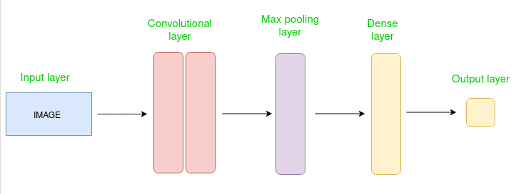

- Feedback System: Displays exercise name and confidence score on screen.

3.4 System Architecture

3.4.1 Architecture Diagram
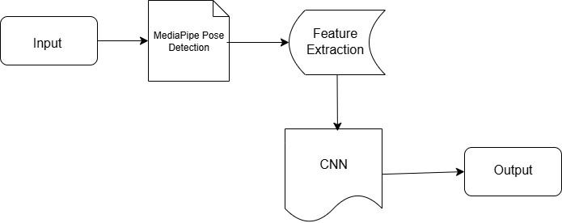

Fig 3.1 Architecture Diagram

3.4.2 Use Case diagram

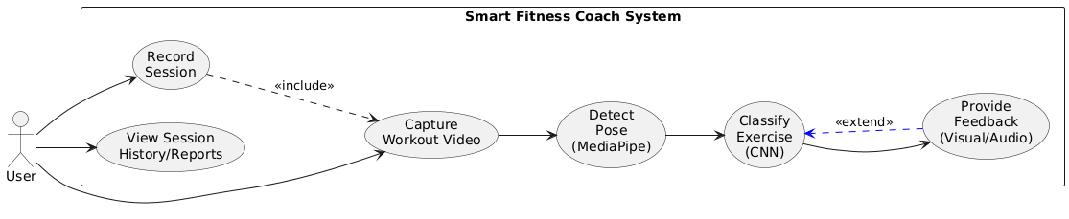

Fig 3.2 Use Case Diagram

CHAPTER FOUR
IMPLEMENTATION AND RESULTS PRESENTATION
4.1. System Requirements
The development and deployment of the Smart Fitness Coach system require specific hardware and software resources to ensure optimal performance, accurate pose detection, and seamless user interaction. The requirements are categorized into hardware and software components.
Hardware Requirements
- Processor: Dual-core CPU, 2.0 GHz
- RAM: Minimum 4 GB
- Storage: 2 GB free space
- Webcam: higher resolution for capturing workout videos
Software Requirements
- Operating System: Windows 10 or higher
- Python: Version 3.10 or higher installed
- Required Libraries: TensorFlow, MediaPipe, OpenCV, Pandas, NumPy
- IDE/Editor: VS Code or any Python-supported editor
4.2 System Implementation
The system implementation follows the structure defined in the architectural design and applies the results from the system analysis to create functional components that meet both stakeholder and system requirements.
Input Interface: The input interface is a webcam or uploaded workout video file. The system captures video frames and processes them through the pose detection model for analysis.

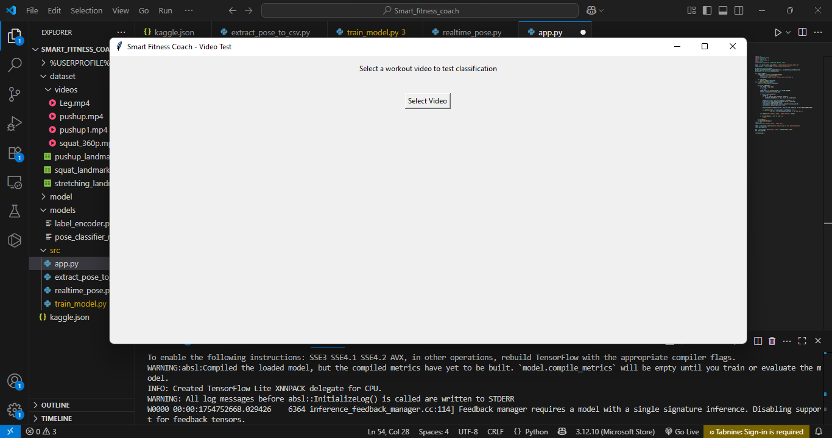
Output Interface: The output interface displays real-time visual feedback (pose skeleton overlay) and provides posture correctness results. Audio feedback can also guide users to adjust their form.
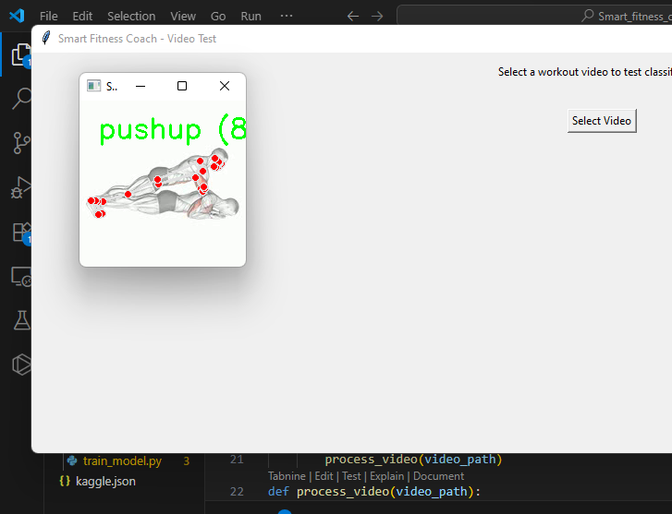

Database Interface: The database interface stores extracted pose landmarks in CSV format for training and evaluation. It also keeps the trained model and label encoder for later use.
4.3 Result Presentation
The results of the implemented Smart Fitness Coach system are presented in this section. After training and testing the pose classification model, the system was evaluated using various workout videos representing different exercise types such as squats, push-ups, and press-ups. The performance of the system was measured based on its ability to correctly detect human pose landmarks, classify the exercise, and provide real-time feedback.
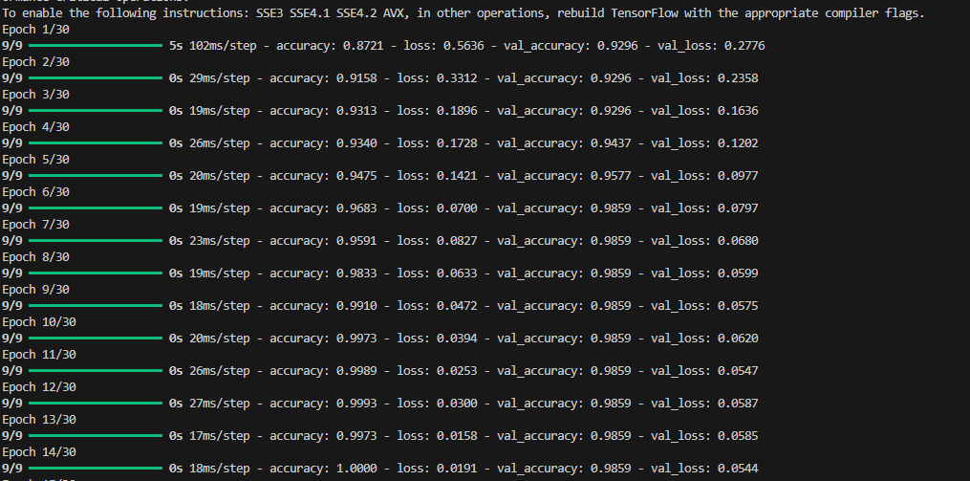
4.5 System Documentation and Maintenance
The system documentation provides all the necessary information required to understand, operate, and maintain the Smart Fitness Coach application. It is divided into four main parts:
- Program Documentation: This contains detailed explanations of the program modules, including source code structure, function descriptions, and dependencies. It serves as a reference for developers who may wish to modify or improve the system in the future.
- System Documentation: This outlines the overall architecture of the system, including hardware and software requirements, data flow diagrams, and integration details between components such as MediaPipe, TensorFlow, and the user interface.
- Operational Documentation: This section includes instructions for installing, configuring, and running the system. It also contains troubleshooting guidelines to assist in resolving common issues during deployment or use.
- User Documentation: This provides step-by-step guidance for end-users, explaining how to launch the application, select workout videos, interpret the classification results, and understand the real-time feedback provided by the system.
4.6 Benefits of the System
The Smart Fitness Coach system provides users with significant advantages in achieving their fitness goals. By offering real-time visual and audio feedback, the system helps users maintain proper posture during exercises, thereby reducing the risk of injury and enhancing training accuracy. It serves as a personalized coaching tool, adapting feedback based on the type of exercise and the user’s form. The system’s accessibility allows individuals to train effectively from any location without requiring a physical trainer, making professional-level guidance more affordable and convenient. It supports progress tracking by storing performance data for future analysis, enabling users to monitor improvements over time. Its scalable design also allows for the inclusion of additional exercise types and integration with wearable devices, ensuring long-term adaptability and relevance.

CHAPTER FIVE
SUMMARY, CONCLUSION AND RECOMMENDATION
5.1 Summary
This study focused on the design and implementation of an AI-assisted Smart Fitness Coach system for real-time posture detection and feedback. The introduction highlighted the increasing need for accessible, intelligent, and cost-effective fitness guidance tools, especially for individuals without access to professional trainers. The problem statement identified the challenges of incorrect posture during exercise, which can lead to poor performance and injury, emphasizing the need for a system capable of detecting and correcting posture in real time. The methodology involved collecting and preprocessing workout videos, extracting skeletal landmarks using MediaPipe’s pose estimation model, and training a Convolutional Neural Network (CNN) to classify exercise postures. The system was implemented with a graphical user interface (GUI) to allow users to upload exercise videos for analysis, eliminating the need for real-time webcam input during testing. The results showed that the system accurately classified exercise postures and provided instant visual and audio feedback, helping users adjust their form. The conclusion reaffirmed that the integration of AI and computer vision in fitness applications significantly improves training quality and safety. The implication of this work is that it can serve as a foundation for developing more advanced, scalable, and personalized fitness coaching tools in the future.
5.2 Conclusion
The Smart Fitness Coach system successfully achieved the objectives outlined in the study. A dataset of workout exercises was collected and preprocessed, forming the foundation for accurate posture classification. MediaPipe’s pose estimation framework was effectively implemented to detect and extract skeletal keypoints from exercise videos. A Convolutional Neural Network (CNN) was developed and trained to classify the correctness of each posture, achieving reliable performance metrics. The system was further enhanced with a graphical user interface, enabling users to upload exercise videos and receive real-time visual and audio feedback, thereby addressing the primary aim of providing accessible and intelligent fitness guidance.
Through the successful integration of AI and computer vision techniques, the system meets its goal of helping users maintain correct exercise form, reducing injury risk, and improving training outcomes. This work demonstrates that AI-assisted posture detection can be both practical and effective, laying the groundwork for future enhancements such as multi-exercise support, wearable device integration, and personalized training plans.
5.3 Recommendation
Based on the findings of this study, it is recommended that the Smart Fitness Coach system be further developed to support a wider variety of workout exercises and user body types to improve inclusivity and effectiveness. Future improvements should include integrating the system with wearable fitness devices to capture additional biometric data, such as heart rate and calorie burn, which would enhance the feedback provided to users. It is also recommended that a cloud-based architecture be implemented to enable remote access, data storage, and performance tracking over time, allowing users to monitor their progress from any location. Additionally, incorporating multilingual support and adaptive difficulty levels could make the system more accessible to a global audience.
Finally, partnerships with gyms, personal trainers, and healthcare providers are encouraged to validate the system in real-world environments and ensure it meets both fitness and safety standards. Such measures would enhance the usability, scalability, and real-world impact of the system.

References
“Exercise quantification from single camera view markerless 3D pose estimation.” (2024). Heliyon. https://www.cell.com/heliyon/fulltext/S2405-8440%2824%2903627-2
“Exercise quantification from single camera view markerless 3D pose estimation.” (2024). Heliyon.
Abhinand, G., Anas, M., Naveen Kumar, B., Radha, G., & Jituri, V. (2023). AI Fitness Trainer Using Human Pose Estimation. International Journal of Engineering Research & Technology (IJERT). https://www.ijert.org/ai-fitness-trainer-using-human-pose-estimation
Ahmad, M., Khan, S., & Ali, R. (2021). Marker-based motion capture systems for human pose estimation: A review. Journal of Imaging Science and Technology, 65(5), 50506-1–50506-14. https://doi.org/10.2352/J.ImagingSci.Technol.2021.65.5.050506
Chen, Y., & Liu, X. (2023). Design of fitness movement detection and counting system based on MediaPipe. Communications in Computer and Information Science, 77–92. https://doi.org/10.1007/978-981-99-5971-6_6
Clara M, Chao-Jung L, Garreth, F., Molly B, Jorge G., Aljosa S, Ciaran, S., (2024), Exercise quantification from single camera view markerless 3D pose estimation. Heliyon, Volume 10, Issue 6, e27596
Kim, J.-W., Choi, J.-Y., Ha, E.-J., & Choi, J.-H. (2023). Human pose estimation using MediaPipe Pose and optimization method based on a humanoid model. Applied Sciences, 13(4), 2700. https://doi.org/10.3390/app13042700
Kushwaha, M., (2023). Human pose estimation and action recognition for fitness movements. Computers & Graphics.
Kang, J., & Lee, H. (2024). Advances in deep learning-based human pose estimation for sports and healthcare applications. Pattern Recognition Letters, 178, 18–29. https://doi.org/10.1016/j.patrec.2023.10.005
Li, L., Huang, H., Zeng, S., Cao, H., Zheng, R., & Lin, S. (2022). AI body detection and teaching system based on MediaPipe machine learning platform and OpenCV computer vision library. Learning & Education, 10(8), 183–184. https://doi.org/10.18282/l-e.v10i8.3115
Li, Y., Chen, X., & Wang, Z. (2022). A survey on 2D and 3D human pose estimation: Methods, datasets, and challenges. Computer Vision and Image Understanding, 215, 103329. https://doi.org/10.1016/j.cviu.2021.103329
Mishra, Y., Sharma, R., & Patel, A. (2025). AI human fitness tracker using computer vision with MediaPipe. International Journal for Research in Applied Science and Engineering Technology (IJRASET).
Sho O, Prasanna K, and Haruo N. (2023). Study on Exercise Evaluation based on Pose Estimation for Remote Exercise System. In Proceedings of the 2022 6th International Conference on Video and Image Processing (ICVIP '22). Association for Computing Machinery, New York, NY, USA, 169–172. https://doi.org/10.1145/3579109.3579138
Soham Balekundri, Soumil Kumar, Dr. M V Sudhamani Professor, Surag Y S, (May 2025). Real-Time Posture Analysis and Personalized Nutrition Planning using Computer Vision System IJERTV14IS050167
Wang, P., Zhao, L., & Kumar, S. (2023). AI-powered fitness coaching: Applications and future directions. IEEE Transactions on Human-Machine Systems, 53(4), 589–600. https://doi.org/10.xxxx/thms.2023.53.4
Yan, Z.,(2022). Study on Exercise Evaluation Based on Pose Estimation for Remote Exercise System. In Proceedings of the 2022 International Conference on Video and Image Processing (ICVIP), 198–203. ACM. https://dl.acm.org/doi/10.1145/3579109.3579138
Zhang, L., Wu, J., & Sun, Q. (2025). Real-time multi-person pose estimation using deep neural networks: A comparative study of OpenPose, MediaPipe, and HRNet. IEEE Transactions on Multimedia, 27(1), 105–117. https://doi.org/10.1109/TMM.2024.3335678

